**Class 9 Task List**

**Team Members (except PL):**

1. Open the **Final Design Report** and the **Final Design Report Rubric**.
2. Review all the components that comprise the Final Design Report.
3. Open the **Final Design Presentation** and the **Final Design Presentation Rubric**.
4. Review all the components that comprise the Final Design Presentation.
5. Help the Project Lead fill out the Gantt Chart by discussing what tasks each team member will be responsible for.

**Project Lead:**

1. Open the team’s Gantt Chart in Microsoft Project using VMWare. You will be adding many more tasks to it to keep your team on track to finish the rest of the project this semester. **There is a partial sample of what it will look like on the following page.**
2. Add 3 new **Tasks** called **Verifications, Final Design Report** and **Final Design Presentation.**
3. Under **Verifications**, insert rows and add tasks for every requirement from your approved Requirements document **INCLUDING THE SYSTEM LEVEL REQUIREMENTS** (ex. FUN 2.1; FUN 2.2; …; STR 2.1; STR 2.2; …; UI 2.1; UI 2.2; …).
4. Highlight all the Tasks created for the Requirements and click the **Indent Task** button in Microsoft Project  . This will make them **Subtasks** under the overall **Verifications** process.
5. Under **Final Design Report**, insert rows and add tasks for every aspect in the Final Design Report (ex. Formatting, Cover Page; Executive Summary; Table of Contents…).
6. Highlight all these tasks and click the **Indent Task** button in Microsoft Project  . This will make them **Subtasks** under the overall **Final Design Report** process.
7. Repeat this for the **Final Design Presentation.**
8. Insert rows as needed and add **Milestones** (make the **Duration** 0 days), for the **Final Design Presentation Rehearsal, Final Design Presentation for Grade** and the **Final Design Report.**
9. Assign either **Durations** or **Start/Finish** dates to all the subtasks. Plan these so you will complete all the necessary items before their respective Milestone. Leave time in the schedule for your team to compile and review the report before submitting it. Your presentation needs to be complete on the rehearsal date.
10. Assign team members as **Resources** to every subtask. **Note that each team member needs to write verifications for AT LEAST two requirements.**
11. Finish by assigning any **Predecessors** and adding a **% Complete** column if you don’t have one already.
12. Click the area next to **Task Name** to select all the contents in the spreadsheet 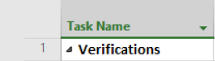
13. Open a shared Google Sheet, click in cell A1 and paste the contents from Microsoft Project.
14. Discuss all responsibilities and ensure that all team members are on the same page.

**Gantt Chart Example**

Note that your team should have more subtasks listed, complete the Duration or Start/End, add more Predecessors as necessary, assign Resource Names, and update the % Complete throughout the rest of the semester.

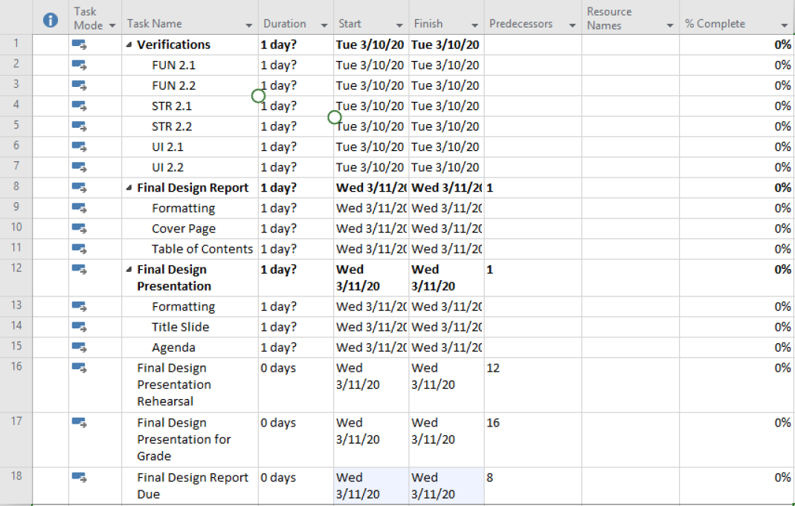

* All team members can access and update the shared Gantt Chart in Google Drive. Team members should be updating the “% Complete” column continuously.
* This means, as you work on and/or complete a task, go on to the Gantt and update the column with the tasks you are completing or have completed.
* Don’t forget to save the Gantt chart as a new version each time you update.
* Start saving it as “Gantt 1”, then the next person will update and save as “Gantt 2,” etc.

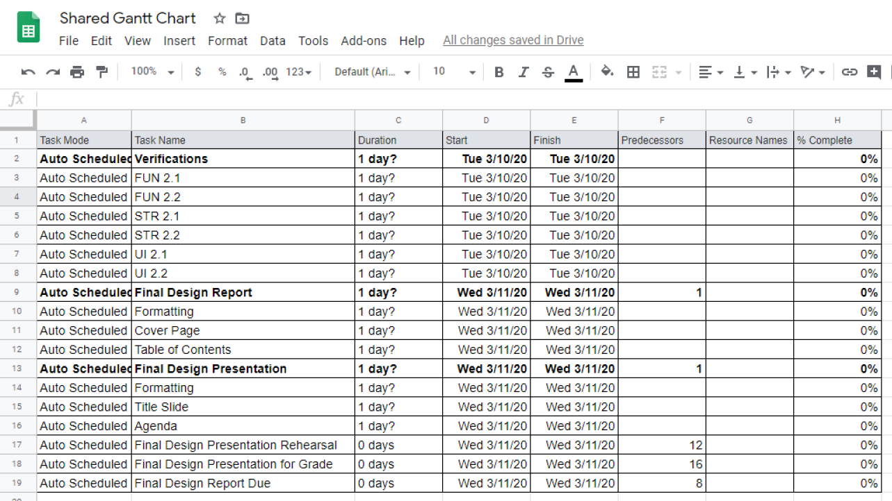

1. All team members should pull up the **Peer Presentation Evaluation Form** and fill in the header and the pair/trio member names. If you are a team of 6+ members, duplicate the table within the same document. Save document as **LastName_FirstName_PresentationEvaluation**
2. The pair/trio that is presenting should put one laptop facing themselves and another facing the remaining team members. Mute all the volume on all the laptops so there isn’t feedback. **Make sure that the presenter’s laptop is muted but the Zoom application is NOT muted.** The presenter’s laptop should be recording during their presentation. **Call the instructor/UCA over to confirm that you have set this up properly.**
3. Present PowerPoint presentations and evaluate the presenters using the Peer Presentation Evaluation Form.

**By the start of Class 09.**

**Due by the end of Class 09:**

* Gantt Chart shared with all team members and have team members assigned to every task.
* Understand what tasks you are responsible for and when you need to complete them by.
* Schedule team meetings as necessary.
* Update the % complete column in the shared Gantt Chart as you work on your tasks.